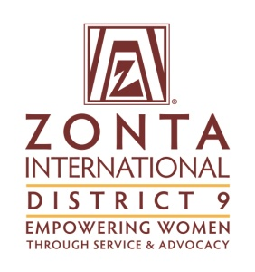

*"Zonta International is a leading global organization of professionals empowering women worldwide through service and advocacy"*

Address ⬩ City, State, Zip ⬩ USA

Tel/Fax 000-000-0000 ⬩ Cell 000-000-0000 ⬩ Email yourname@yahoo.com

www.zonta.org ⬩ www.zontadistrict9.org